**Problem Definition** Disaster Recovery with IBM Cloud Virtual Servers

**Context:**

In today's digital landscape, businesses rely heavily on their IT infrastructure to operate efficiently. Unforeseen disasters, such as natural calamities, hardware failures, cyberattacks, or human errors, can disrupt normal operations and lead to data loss, revenue loss, and damage to an organization's reputation. To mitigate these risks, it is essential to have a robust Disaster Recovery (DR) plan in place. This problem definition focuses on implementing a disaster recovery solution using IBM Cloud Virtual Servers.

1. **Problem Statement:**

The problem at hand is to establish a comprehensive Disaster Recovery strategy for an organization's critical workloads hosted on IBM Cloud Virtual Servers. This strategy should ensure minimal downtime, data integrity, and the ability to swiftly recover from disruptive events.

The following key aspects need to be addressed:

**a. Infrastructure Assessment:**

* + Evaluate the existing IBM Cloud Virtual Servers environment, including network configurations, storage solutions, and server workloads.
  + Identify critical applications and data that require protection and prioritize them based on their importance to the business.

**b. Disaster Recovery Plan:**

* + Develop a well-defined Disaster Recovery plan that outlines the processes, procedures, and responsibilities during a disaster event.
  + Determine Recovery Time Objectives (RTO) and Recovery Point Objectives (RPO) for each application and workload to establish recovery goals.
  + Select appropriate backup and replication methods to create a redundant and resilient infrastructure.

**c. IBM Cloud Virtual Servers Configuration:**

* + Configure the IBM Cloud Virtual Servers for both primary and secondary data centers to ensure data synchronization and failover capabilities.
  + Implement redundancy and failover mechanisms to maintain service availability in case of a disaster.
  + Ensure compatibility and scalability of virtual server instances for seamless recovery.

**d. Data Backup and Replication:**

* + Implement backup and replication solutions to create copies of data and applications in real-time or near-real-time to a secondary location.
  + Monitor and manage the backup and replication processes to ensure data consistency and integrity.

**e. Testing and Validation:**

* + Conduct regular DR testing to validate the effectiveness of the recovery plan.
  + Document test results and make necessary adjustments to the plan based on findings.
  + Ensure that the recovery process is well-documented and easily accessible to relevant personnel.

**f. Security and Compliance:**

* + Ensure that the DR solution complies with industry-specific regulations and security standards.
  + Implement encryption and access controls to protect sensitive data during the recovery process.

**g. Monitoring and Alerting:**

* + Set up continuous monitoring and alerting systems to detect and respond to potential issues in real-time.
  + Establish clear escalation procedures to address critical incidents promptly.

1. **Expected Outcomes:**
   * A fully documented Disaster Recovery plan tailored to the organization's specific needs.
   * Implementation of IBM Cloud Virtual Servers configurations that support disaster recovery objectives.
   * Regularly tested and validated disaster recovery processes to ensure readiness.
   * Enhanced data protection, reduced downtime, and minimized data loss in the event of a disaster.
   * Improved security and compliance measures to safeguard critical data.
2. **Stakeholders:**
   * IT Operations Team
   * Disaster Recovery Team
   * IBM Cloud Service Providers
   * Compliance and Security Teams
   * Business Continuity Managers
   * Executive Leadership
3. **Constraints and Challenges:**
   * Budget limitations for implementing redundancy and backup solutions.
   * Compatibility issues with legacy systems and applications.
   * Complex data synchronization requirements for geographically dispersed virtual servers.
   * Regulatory constraints and compliance considerations.
   * Staff training and awareness for effective disaster recovery execution.

Solving the problem of Disaster Recovery with IBM Cloud Virtual Servers requires careful planning, robust technology solutions, and a commitment to maintaining and testing the recovery plan regularly to ensure its effectiveness.

**Design Thinking of Disaster Recovery with IBM Cloud Virtual Servers**

Design thinking is a problem-solving approach that emphasizes empathy for end-users, creative brainstorming, prototyping, and iterative development. When applied to disaster recovery with IBM Cloud Virtual Servers, it can help create a robust and user-centric disaster recovery plan. Here's a step-by-step guide to applying design thinking principles to disaster recovery with IBM Cloud Virtual Servers:

1. **Empathize:**
   * Understand the needs and concerns of your organization and its stakeholders. Identify key assets, applications, and data that require protection.
   * Conduct interviews or surveys with IT staff, business leaders, and end-users to gather insights into their expectations and priorities for disaster recovery.
2. **Define:**
   * Define clear goals and objectives for your disaster recovery plan. Consider factors such as Recovery Time Objective (RTO) and Recovery Point Objective (RPO) to determine acceptable downtime and data loss.
   * Identify potential threats and risks, such as natural disasters, cyberattacks, or hardware failures, that could impact your IBM Cloud Virtual Servers.
3. **Ideate:**
   * Organize brainstorming sessions with cross-functional teams to generate innovative ideas for disaster recovery strategies. Encourage diverse perspectives and explore various options.
   * Consider using IBM Cloud services and tools, such as IBM Cloud Virtual Servers, IBM Cloud Object Storage, and IBM Resiliency Orchestration, in your ideation process.
4. **Prototype:**
   * Develop prototypes or proof-of-concept solutions based on the ideas generated during the ideation phase. Use IBM Cloud Virtual Servers and other relevant IBM Cloud services to build and test these prototypes.
   * Ensure that your prototypes address both technical and user experience aspects of disaster recovery.
5. **Test:**
   * Conduct thorough testing of your disaster recovery prototypes. Simulate different disaster scenarios and evaluate the effectiveness of your recovery strategies.
   * Gather feedback from stakeholders, IT teams, and end-users to refine and improve the prototypes.
   * Based on the feedback and results of testing, select the most effective disaster recovery strategy for your organization.
   * Use IBM Cloud Virtual Servers to implement the chosen strategy, ensuring that it meets your RTO and RPO requirements.
6. **Monitor and Iterate:**
   * Continuously monitor the performance of your disaster recovery plan using IBM Cloud monitoring and management tools.
   * Regularly update and refine your plan based on changing business needs, technology advancements, and emerging threats.
7. **Communicate:**
   * Develop a clear communication plan to keep all stakeholders informed about the disaster recovery process, including IT staff, executives, and end-users.
   * Ensure that everyone knows their roles and responsibilities in case of a disaster.
8. **Document:**
   * Document your disaster recovery plan, including procedures, configurations, and contact information, and make it easily accessible to relevant teams.
   * Keep the documentation up-to-date to reflect any changes in your IBM Cloud Virtual Servers environment.
9. **Train:**
   * Provide training and awareness programs for IT staff and end-users to ensure they understand the disaster recovery plan and their respective roles.

By following these design thinking principles, you can create a disaster recovery plan for IBM Cloud Virtual Servers that is not only technically robust but also aligned with the needs and expectations of your organization and its stakeholders. Remember that design thinking encourages flexibility and adaptability, allowing you to continually improve your disaster recovery strategy over time.

**Innovation Of Disaster Recovery with IBM Cloud Virtual Servers**

Innovating in disaster recovery with IBM Cloud Virtual Servers involves leveraging advanced technologies and strategies to enhance resilience, reduce downtime, and improve overall recovery capabilities. Here are some innovative approaches to disaster recovery using IBM Cloud Virtual Servers:

1. **Hybrid Cloud Disaster Recovery:**
   * Implement a hybrid cloud disaster recovery solution by combining on-premises infrastructure with IBM Cloud Virtual Servers. This provides scalability, flexibility, and cost-efficiency.
   * Use technologies like IBM Cloud Direct Link to establish high-speed, secure connections between on-premises data centers and IBM Cloud.
2. **Automation and Orchestration:**
   * Implement automation and orchestration tools, such as IBM Resiliency Orchestration, to streamline disaster recovery processes.
   * Automate failover and failback procedures to minimize manual intervention and reduce recovery time.
3. **Real-time Data Replication:**
   * Utilize technologies like IBM Cloud Object Storage to enable real-time data replication and synchronization between production and recovery environments.
   * This ensures minimal data loss and near-instant failover in case of a disaster.
4. **AI and Predictive Analytics:**
   * Integrate artificial intelligence and predictive analytics into your disaster recovery plan. AI can help monitor system health and predict potential issues before they become critical.
   * IBM Watson can be used for predictive maintenance and intelligent incident response.
5. **Disaster Recovery as a Service (DRaaS):**
   * Consider leveraging IBM Cloud's Disaster Recovery as a Service (DRaaS) offerings, which provide managed and automated disaster recovery solutions.
   * DRaaS simplifies the setup, management, and testing of your disaster recovery environment.
6. **Immutable Infrastructure:**
   * Implement immutable infrastructure practices, where server configurations are never modified after deployment. If changes are required, new instances are created.
   * This approach enhances security and recoverability.
7. **Multi-Region Deployment:**
   * Deploy redundant IBM Cloud Virtual Servers in multiple geographic regions to ensure high availability and disaster recovery capabilities.
   * Implement global server load balancing for automatic traffic redirection in case of a regional outage.
8. **Zero Trust Security:**
   * Embrace a Zero Trust security model to protect your disaster recovery environment. Ensure that authentication, access control, and encryption are enforced rigorously.
   * Utilize IBM Cloud Security solutions to enhance cybersecurity.
9. **Continuous Testing and Simulation:**
   * Regularly conduct disaster recovery testing and simulations to validate the effectiveness of your recovery plan.
   * Use tools like IBM Resiliency Orchestration to automate and schedule testing routines.
10. **Containerization and Kubernetes:**
    * Containerize critical applications and use Kubernetes for container orchestration. This approach enhances portability and simplifies disaster recovery.
11. **Blockchain for Data Integrity:**
    * Implement blockchain technology to maintain the integrity of critical data and transaction records, ensuring they remain tamper-proof during recovery.
12. **Edge Computing for Resilience:**
    * Leverage edge computing resources provided by IBM Cloud to distribute critical workloads closer to end-users. This reduces latency and enhances resilience.
13. **Employee Training and Awareness:**
    * Invest in ongoing training and awareness programs for your IT staff to ensure they are well-prepared for disaster recovery procedures.
14. **Regulatory Compliance:**
    * Ensure that your disaster recovery plan complies with relevant industry and governmental regulations, especially in highly regulated sectors like healthcare or finance.
15. **Data Lifecycle Management:**
    * Implement intelligent data lifecycle management practices, where data is automatically categorized, archived, and purged according to policies to reduce storage costs and streamline recovery.

**Development of Disaster recovery with IBM Cloud virtual:**

**Developing a disaster recovery plan with IBM Cloud Virtual Servers involves several key steps. Here's an overview of the process:**

**1.** **Assessment and Planning:**

- Identify critical data and applications that need to be protected.

- Determine recovery time objectives (RTO) and recovery point objectives (RPO) for these resources.

- Decide on the appropriate IBM Cloud Virtual Server configurations for your primary and recovery sites.

2. **Backup and Replication:**

- Implement regular backups of your data and server configurations.

- Set up data replication to a secondary IBM Cloud Virtual Server or another location to ensure data redundancy.

3. **Failover and Failback Procedures**:

- Create a documented procedure for initiating failover to the secondary site in case of a disaster.

- Define the steps for failing back to the primary site once it's restored.

4. **Network Configuration:**

- Ensure proper network connectivity between the primary and secondary sites.

- Use VPNs or Direct Link to establish secure communication between sites.

5. **Monitoring and Testing:**

- Implement monitoring tools to continuously track the health of your primary and secondary resources.

- Regularly test your disaster recovery plan to ensure it works as expected.

6. **Automation**:

- Use automation tools to streamline failover and failback processes, reducing manual intervention.

7. **IBM Cloud Services:**

- Leverage IBM Cloud services like IBM Cloud Virtual Servers, IBM Cloud Object Storage, and IBM Cloud Databases to support your disaster recovery strategy.

8. **Data Encryption and Security:**

- Implement encryption for data in transit and at rest to ensure security.

9. **Documentation:**

- Maintain comprehensive documentation of your disaster recovery plan, including contact information for team members and third-party service providers.

10. **Compliance and Regulations:**

- Ensure that your disaster recovery plan complies with any industry-specific regulations and standards.

11. **Regular Updates and Training:**

- Keep your disaster recovery plan up to date with changes in your infrastructure.

- Train your team on the procedures and ensure they are familiar with their roles during a disaster.

12. **Third-Party Solutions:**

- Consider using third-party disaster recovery solutions that are compatible with IBM Cloud, such as Veeam, Zerto, or IBM Resiliency Orchestration.

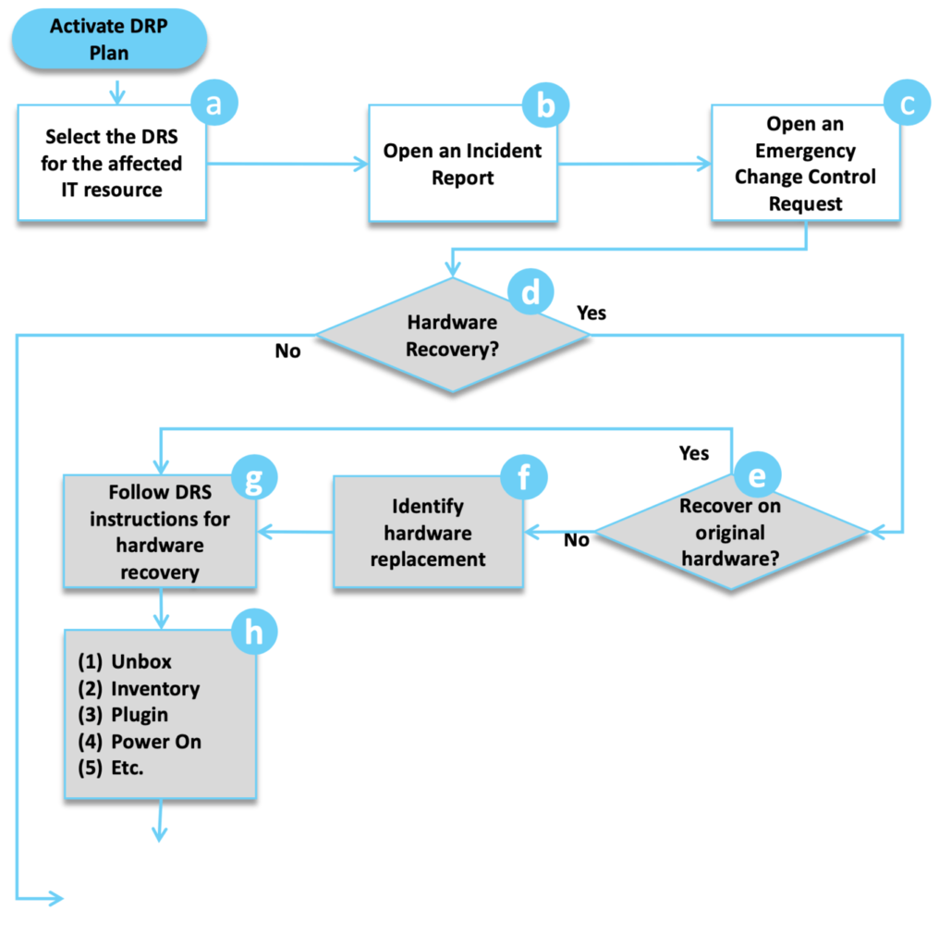

**Needs of the disaster recovery with IBM Cloud virtual**

1. **Assessment and Planning**:

- Identify critical applications and data that need protection.

- Define recovery time objectives (RTO) and recovery point objectives (RPO) to determine how quickly you need to recover and how much data loss is acceptable.

2. **Select IBM Cloud Virtual Servers**:

- Choose the appropriate virtual server configurations based on your requirements.

3. **Data Replication**:

- Implement data replication mechanisms to keep data synchronized between your primary and secondary sites. IBM Cloud offers solutions like IBM Cloud Object Storage and IBM Cloud Block Storage for data replication.

4. **Failover Site**:

- Set up a secondary site in a different geographical region to minimize the risk of a regional disaster affecting both sites.

5. **Automated Failover**:

- Implement automated failover processes to minimize manual intervention during disaster recovery. IBM Cloud services can help with automation and orchestration.

6. **Testing and Validation**:

- Regularly test your disaster recovery plan to ensure it works as expected. This includes testing failover and failback procedures.

7. **Monitoring and Alerting**:

- Implement monitoring and alerting systems to detect issues in real-time and trigger failover when necessary.

8. **Documentation**:

- Maintain detailed documentation of your disaster recovery plan, configurations, and procedures.

9. **Security Considerations**:

- Ensure that security measures are in place to protect data during replication and at the secondary site.

10. **Compliance**:

- Ensure that your disaster recovery plan complies with any industry regulations or standards applicable to your organization.

11. **Regular Updates**:

- Periodically review and update your disaster recovery plan to account for changes in your environment or technology.

12. **Provider Support**:

- Leverage IBM Cloud's support and expertise in disaster recovery solutions. IBM offers services like IBM Resiliency Orchestration to help automate and manage disaster recovery processes.

.

**Developing a disaster recovery plan with IBM Cloud Virtual Servers offers several advantages and fulfills important business needs, including:**

1. **Business Continuity:**

Ensures that your critical applications and data remain accessible, even in the face of disasters like hardware failures, data corruption, or natural disasters.

2. **Data Protection:** Safeguards your data by maintaining redundant copies in a separate location, minimizing the risk of data loss.

3. **Minimized Downtime**: Enables rapid failover to a secondary site, reducing the impact of downtime on your operations.

4. **Cost Efficiency:** IBM Cloud offers pay-as-you-go pricing, allowing you to scale your disaster recovery resources as needed, reducing capital expenditures.

5. **Flexibility**: IBM Cloud Virtual Servers provide a flexible and scalable infrastructure that can be customized to your specific needs.

6. **Security**: IBM Cloud offers security features like encryption, network isolation, and compliance certifications to enhance the protection of your resources.

7. **Global Reach**: IBM Cloud has data centers in multiple regions, allowing you to replicate data and applications across geographic locations for added resilience.

8. **Automation**: You can automate failover processes, reducing the need for manual intervention during disasters.

9. **Monitoring and Reporting**: IBM Cloud provides monitoring tools and reporting capabilities to keep track of the health and performance of your resources.

10. **Compliance**: Helps you meet regulatory requirements by maintaining data redundancy and backup capabilities.

11. **Scalability**: IBM Cloud's virtual servers can easily accommodate your growing disaster recovery needs as your business expands.

12. **Testing and Validation:**

Provides a platform for regularly testing your disaster recovery plan to ensure it works as expected.

13. **Third-Party Integration:**

IBM Cloud supports integration with third-party disaster recovery and backup solutions to enhance your overall strategy.

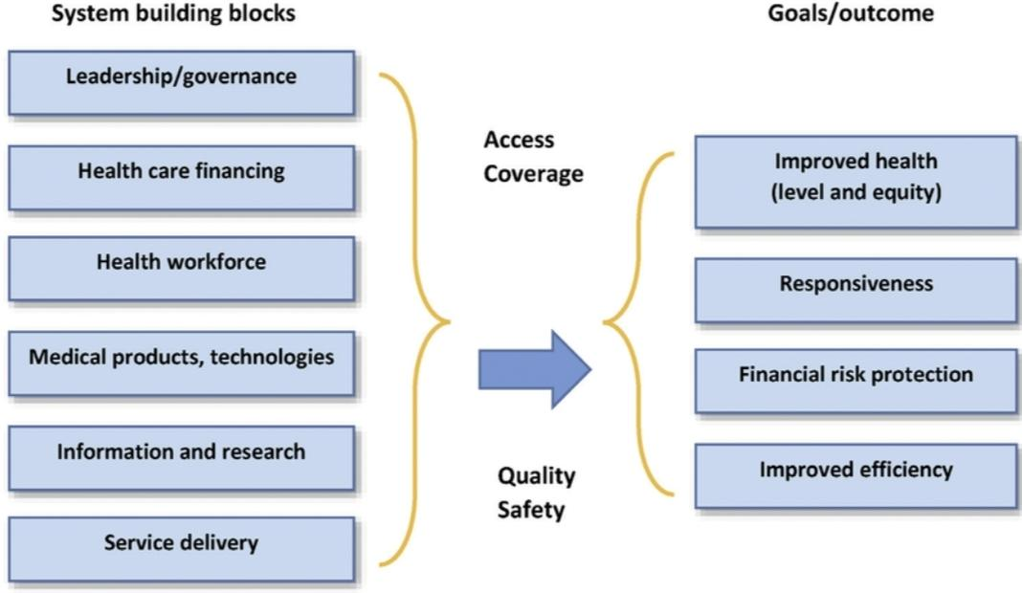

**Developing a disaster recovery plan with IBM Cloud Virtual Servers offers several key uses and benefits for businesses:**

1. **Data Protection**: Safeguard critical data by creating redundant copies and ensuring data integrity in the event of hardware failures, data corruption, or disasters.

2. **Business Continuity**: Ensure uninterrupted operations even in the face of unexpected disruptions, minimizing downtime and maintaining customer confidence.

3. **High Availability:** Leverage IBM Cloud's infrastructure to create a secondary site that can quickly take over operations in the event of a failure in the primary data center.

4. **Cost Efficiency:** IBM Cloud's pay-as-you-go pricing model allows you to only pay for resources when needed, reducing capital expenses associated with traditional disaster recovery infrastructure.

5. **Scalability**: Easily adjust your disaster recovery infrastructure to meet changing business needs, whether it's scaling up or down.

6. **Security:** Utilize IBM Cloud's security features, including encryption, access controls, and network isolation, to enhance data protection.

7. **Global Reach:**

IBM Cloud has data centers in various regions, enabling you to replicate data and applications across geographic locations for added resilience.

8. **Automation**:

Implement automated failover and failback processes to minimize manual intervention during disaster recovery scenarios.

***Disaster recovery involves a range of techniques and strategies to ensure that an organization can quickly and effectively recover from a disaster or significant disruption. Some common techniques include:***

1. **Data Backups:** Regularly backing up critical data and systems is fundamental. This can be done using techniques like full backups, incremental backups, and differential backups. Storing backups both on-site and off-site is crucial.

2**. Redundancy:**

Implement redundancy in critical systems. This can include redundant servers, network connections, and power sources. Redundancy helps maintain service availability in case of hardware failures.

3. **Disaster Recovery Plan (DRP):**

Develop a comprehensive DRP that outlines the procedures, roles, and responsibilities in the event of a disaster. Test the plan regularly to ensure its effectiveness.

4. **Virtualization**: Using virtualization technologies allows for quick deployment of backup systems and applications in case of a disaster. Virtual machines can be more easily replicated and moved to alternative locations.

5. **Cloud-Based Services:**

Leveraging cloud services for data storage and application hosting can enhance disaster recovery. Many cloud providers offer built-in redundancy and disaster recovery features.

6. **Off-Site Locations:**

Storing backups and critical data at geographically distant off-site locations ensures that data is safe in case of a localized disaster.

7. **High Availability (HA) Clusters:**

Deploying high availability clusters can ensure system availability by automatically shifting workloads to healthy nodes in the event of a failure.

8. **Data Mirroring:**

Data mirroring involves duplicating data in real-time on separate storage systems. This ensures data consistency and availability.

9. **Testing and Simulation:**

Regularly testing disaster recovery plans through simulations and drills helps identify weaknesses and improve the recovery process.

10. **Documentation**:

Maintain detailed documentation of system configurations, procedures, and recovery steps. This can be invaluable during a disaster.

11. **Communication Plans:**

Establish communication plans to keep stakeholders informed during a disaster. This includes employees, customers, and relevant authorities.

12. **Security Measures:**

Implement security measures to protect data during recovery, such as encryption and access controls.

13. **Risk Assessment:**

Continuously assess potential risks and update the disaster recovery plan accordingly.

14. **Vendor Support:**

For third-party applications and services, ensure you have a clear understanding of vendor support and disaster recovery options.

15. **Employee Training:**

Train employees on their roles and responsibilities in the event of a disaster, and ensure they understand the recovery procedures.

The specific techniques and strategies a business employs will depend on its unique requirements, budget, and the criticality of its systems and data.

